Tagging Exam Setup Master in Academic Template

Step 1 – Go to CMS >> Academics >> Generate >> Academic Batch
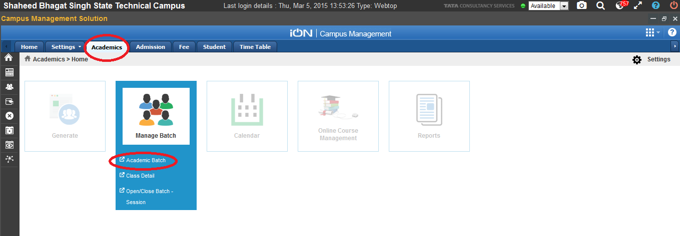
Click on Search to select the Batch for which you want to configure exam set up
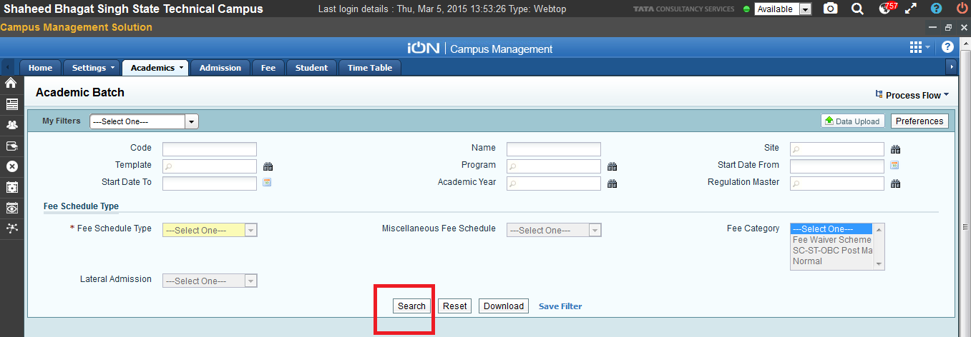
Step 2 - Select the Batch for which you need to configure exam setup and click edit. Select the batch which is associated with the template for which you have configured the Exam Configuration.
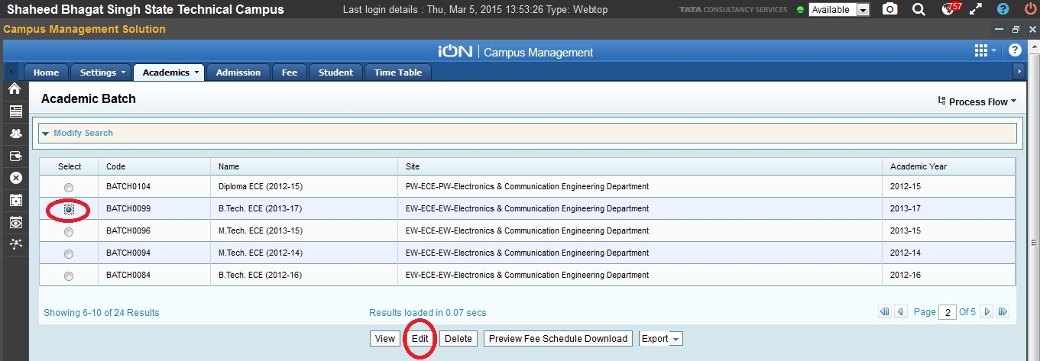
In The Above Case, We have done Exam Configuration for the template associated with the selected Batch i.e B.Tech ECE(2013-17)
Refer to below Screen in order to check the template associated with Batch.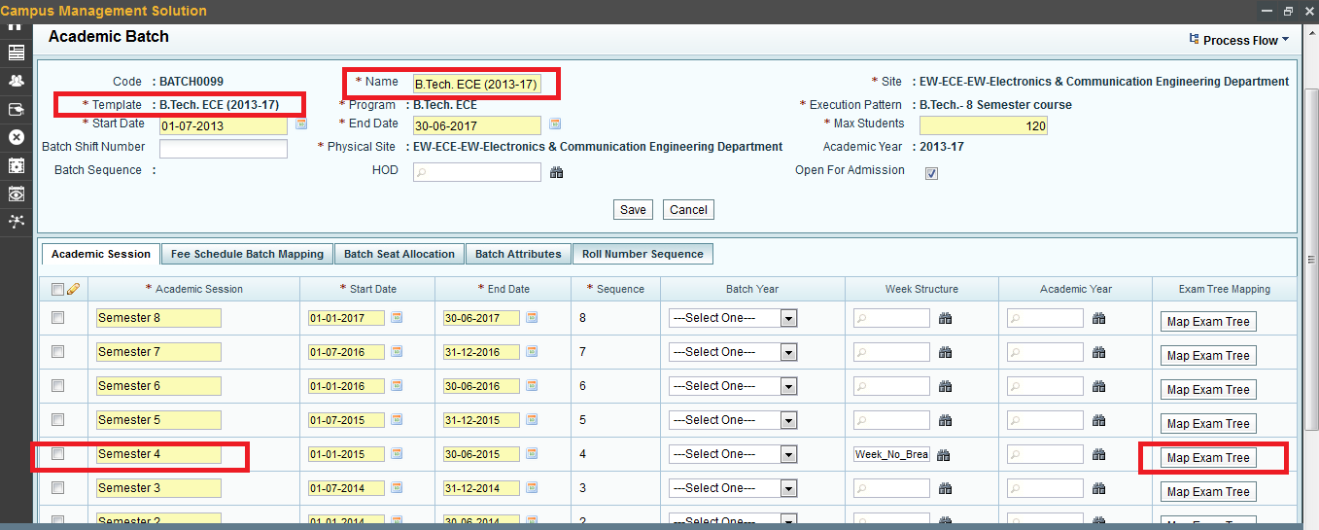
We have done the Exam Configuration in the template B.tech ECE (2013-17)
Select the Same Semester for which Exam Configuration was done in template of the Batch and click on Map Exam Tree.

Step 3 – After Clicking on Map Exam Tree , Below Screen will appear.
Now tag the Exam tree which you have used to create setup Master and Tag the Setup Master created for Exam in Exam Setup Master Tab and Click Save.

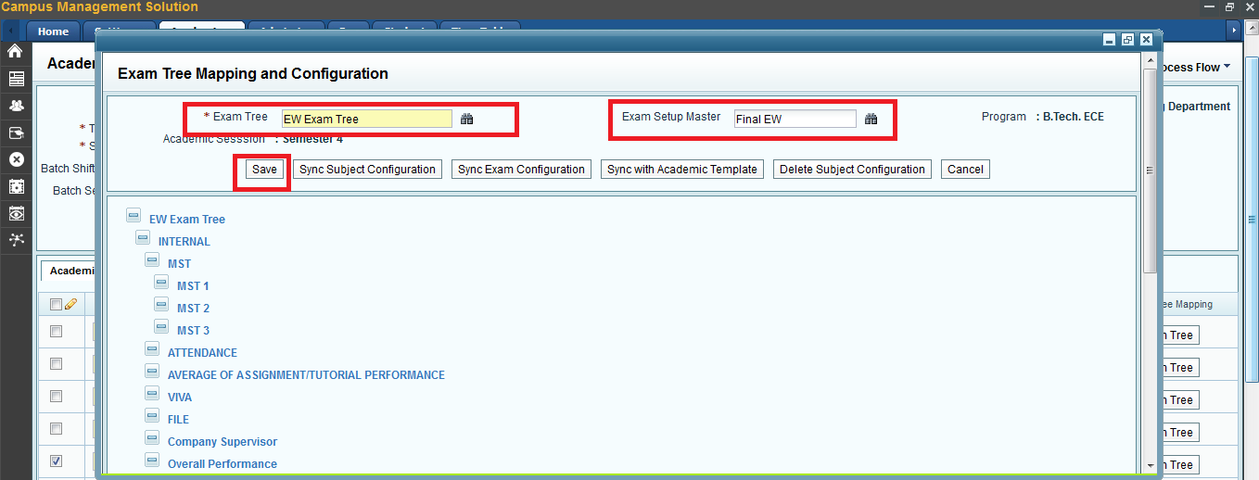

Step 4 - After saving Click on
- Sync with academic template
- Sync exam Configuration
- Sync Subject Configuration
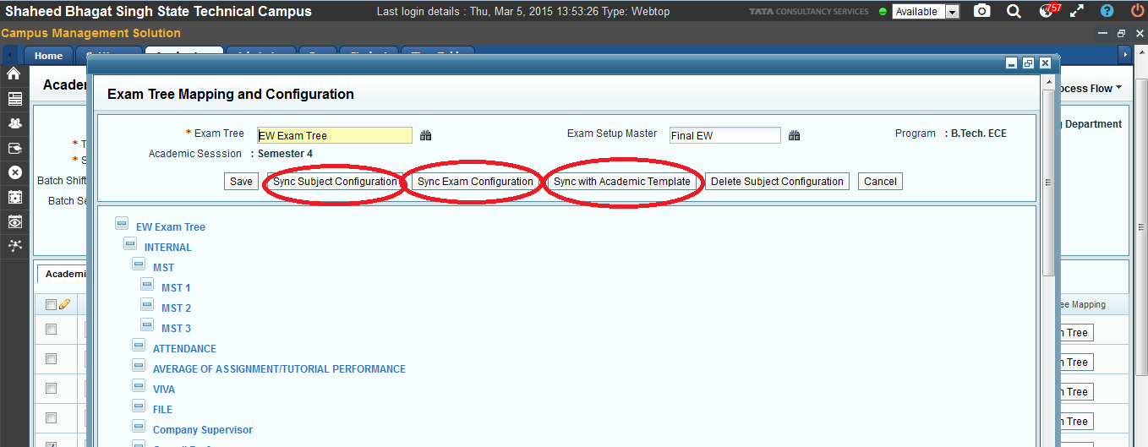
Step 5 – To check weather the Configuration has been done successfully or not. Click on any Exam Tree Node.It will display you the subjects.

Click on MST 1 , the below screen will appear. It will Display all Subjects for which you need to capture score for MST1.
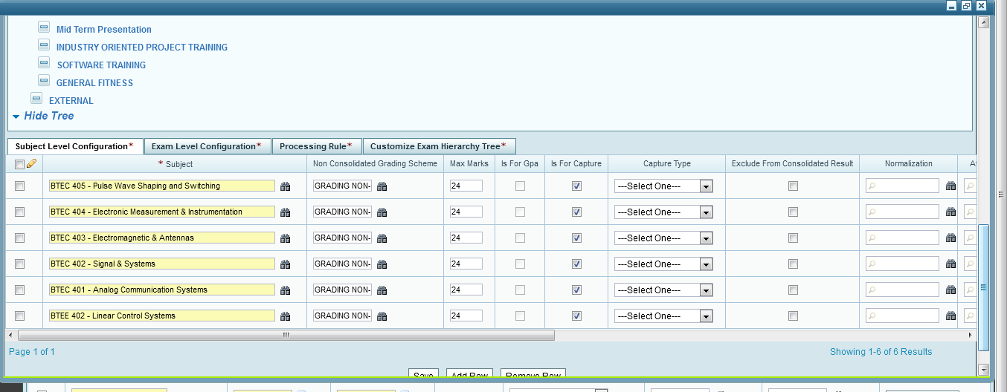

The Configuration at Academic Batch is Completed.

NOTE : Please make sure that the tagging of setup master should be same at academic template and the batch associated with that template.

